A Minor Project Synopsis on

**COVID - 19 Predictions and Analysis Using CNN**

Submitted to Manipal University, Jaipur

Towards the partial fulfillment for the Award of the Degree of

**BACHELORS OF TECHNOLOGY**

In Information Technology

2019-2020

By

Mayank Aggarwal

189302045

Vanshika Mediratta

189302025



Under the guidance of

Dr Nripendra Narayan Das

**Department of Information Technology**

**School of Computing and Information Technology**

**Manipal University Jaipur**

**Jaipur, Rajasthan**

**Introduction**

Coronavirus disease 2019 (COVID-19) is a contagious disease caused by severe acute respiratory syndrome coronavirus 2 (SARS-CoV-2). The first case was identified in Wuhan, China, in December 2019. After that in 2020, the virus started spreading across the world affecting everybody and resulting in depletion in many other things like the economy, living conditions, obstruction in development, etc. COVID-19 has become the hot topic of the decade and analysis and prediction can benefit in discovering new patterns and trends in reports gathered through various international sources and even enforce precautionary measures for the future. The goal of this project is to look into some specific trends and patterns with the help of various upcoming Deep Learning Algorithms which can open the gate of discoveries and findings. The major Deep Learning Algorithm which will be used and implemented is CNN (Convolutional Neural Networks) which can take in an input image, assign importance (learnable weights and biases) to various aspects/objects in the image, and be able to differentiate one from the other.

**Motivation**

COVID-19 pandemic has affected all of our lives in the worst possible manner. If we could use our knowledge in the best possible manner and incorporate it with this project, we believe it could lead to some answers on this global issue. The primary motivation behind all this is that like the world was not at all ready for the pandemic with any kind of measures which could help in maintaining social stability and social order. Machine Learning and Deep learning algorithms can help out in figuring out the possible outcomes in the near future of COVID-19. The analysis part can help understand the patterns and trends by which increase in COVID-19 formulated, which is essential for the responsible organisations to be ready beforehand so that major crises like economic crises do not occur in such situations. We also want to use our Machine Learning skills and refine them so that in future we could do projects with better efficiency.

**Project Objective**

* Objective is to visualize, clean and model the algorithm to give out the best possible and accurate result.
* We could apply this result to further deepen our understanding of the disease by performing deep learning algorithms like CNN for classification of a healthy and infected lung.

|  |  |
| --- | --- |
| PROS | CONS |
| Cleaned dataset is always easier to work with and the cross-validation strategy is more effective in this manner. | Data Cleaning can be difficult to deal with if the dataset contains noisy and duplicate images. |
| Deep Learning gives benefits like more time saving, less expensive, easy to operate in such kind of analysis | Practically we need ~100% accuracy as we can’t wrongly identify the patients as it might lead to further spread of disease which is highly discouraged. |
| Analysis using modern techniques can be helpful in finding out some unique trends and patterns which traditional techniques could not overcome. | Usually the implementation of modern techniques requires proper data pre-processing which can be a really tedious task. |
| Exploratory data analysis gives us root basic understanding of the dataset. This helps us determine the class imbalance and all the other outliers. | Exploratory Data Analysis can take some time to get a hold onto and dig well enough to explore/mine the dataset carefully and thoroughly. |

**Methodology/ Planning of work:**

* We plan on researching the use of ML with predicting Coronavirus based on research papers.
* Studying about CNN, deep learning and various applications of this.
* After acquiring enough knowledge, the next step is finding the dataset for the project.
* We then study the features as well as X-ray images to get an understanding of what the project expects.
* We then perform exploratory data analysis to visualise the minute details and get a better understanding of the data.
* Data cleaning is done to remove any outliers present and avoid overfitting or underfitting and perform data augmentation.
* Train our CNN model with accurate layers and repeat the process until best accuracy is obtained.
* Use the model on test data to get results.

Gantt Chart is attached here for reference:

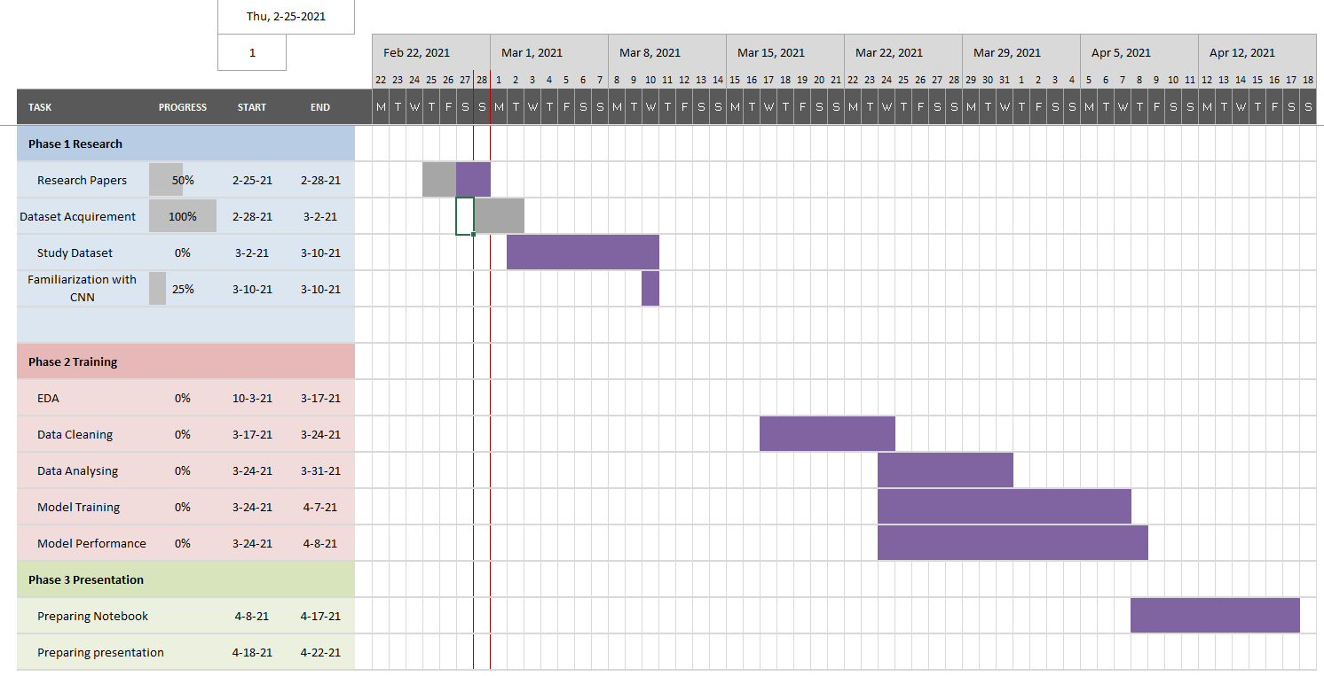

We hope to complete the entire project by 22nd April 2021.

**Facilities required for proposed work:**

SOFTWARE

1. Windows 10

2. Python Programming Language using Machine Learning libraries (SciKit Learn, Tensorflow, NumPy, Pandas, SciPy, etc.) for Data Prediction.

3. Tableau or Power BI for Data Analysis

HARDWARE

1. 40GB space in hard disk

2. Core i3 processor

3. At least 8GB RAM

**Bibliography/References**

Dataset: <https://www.kaggle.com/tawsifurrahman/covid19-radiography-database/code?datasetId=576013&sortBy=voteCount>

<https://www.kaggle.com/mrhippo/covid-19-lungs-x-rays-prediction>

Majeed, T., Rashid, R., Ali, D., & Asaad, A. (2020). Covid-19 detection using cnn transfer learning from x-ray images. *medRxiv*.

Islam, M. Z., Islam, M. M., & Asraf, A. (2020). A combined deep CNN-LSTM network for the detection of novel coronavirus (COVID-19) using X-ray images. *Informatics in medicine unlocked*, *20*, 100412.

Heidari, M., Mirniaharikandehei, S., Khuzani, A. Z., Danala, G., Qiu, Y., & Zheng, B. (2020). Improving the performance of CNN to predict the likelihood of COVID-19 using chest X-ray images with preprocessing algorithms. *International journal of medical informatics*, *144*, 104284.

Alazab, M., Awajan, A., Mesleh, A., Abraham, A., Jatana, V., & Alhyari, S. (2020). COVID-19 prediction and detection using deep learning. *International Journal of Computer Information Systems and Industrial Management Applications*, *12*, 168-181.